Pair Programming 5 Turn In

Name: _____Matthew Krahel _________ Username: _______C1010B11_________

Partner name: _______Blake Hodges___________ Partner username: ____C1010B06________

_X_ I certify that my partner did work with me on these pair programming activities.

**If you or your partner has not been contributing approximately equally, please let me know what’s going on and give your opinion on whether or not you feel it might be time to change partners.**

SCORE: ____________ (to be filled in by instructor)

5a (2 points)

**/*File: pp5a.cpp**

**\* Author: Matthew Krahel and Blake Hodges**

**\* This program requests 2 numbers from the**

**\* user and calls a function to swap the**

**\* numbers as a reference variable.**

**\*/**

**// Identifying the libraries and namespaces used in this program**

**#include <iostream>**

**using namespace std;**

**// Declare Functions**

**void myswap(double& varA, double& varB);**

**// Begin Main Function**

**int main()**

**{**

**// Declare the variable**

**double varX, varY; //2 variables to receive and swap**

**//Request variables from user**

**cout << "Enter first number: ";**

**cin >> varX;**

**cout << "Enter second number: ";**

**cin >> varY;**

**//Call the function to swap the numbers**

**myswap(varX, varY);**

**//Output the swapped variables**

**cout << "First number: ";**

**cout << varX;**

**cout << "\nSecond number: ";**

**cout << varY;**

**cout << "\n";**

**return;**

**}**

**// Function for swapping 2 variables**

**void myswap(double& varA, double& varB)**

**//Precondition: Receive 2 numbers to be swapped**

**//Postcondition: Output the 2 numbers swapped**

**{**

**//Declare temporary variable**

**double tempVar;**

**//Swap 2 variables**

**tempVar = varA;**

**varA = varB;**

**varB = tempVar;**

**return ( 0 );**

**}**

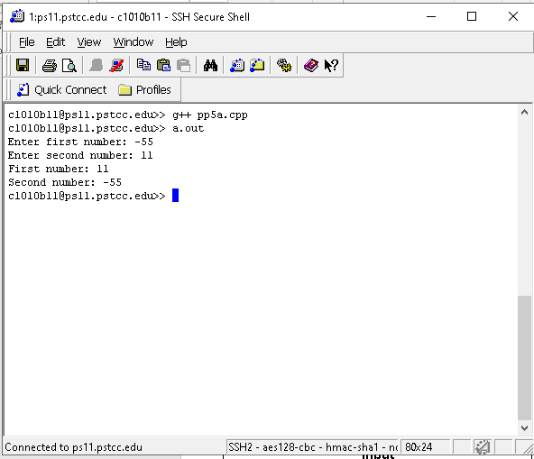

5b (5 points)

**/*File: pp5b.cpp**

**\* Author: Matthew Krahel and Blake Hodges**

**\* This program requests 1 number from the**

**\* user and calls a function to determine the**

**\* number's attributes.**

**\*/**

**// Identifying the libraries and namespaces used in this program**

**#include <iostream>**

**using namespace std;**

**// Declare Functions**

**void figureit(double intA, bool& div2, char& sign, int& rounded);**

**// Begin Main Function**

**int main()**

**{**

**// Declare the variables**

**double intX; //Value to get from user**

**bool divX; //Output for even or not**

**char signX; //Output for value's sign**

**int roundedX; //Output for rounded value**

**do{**

**//Request variables from user**

**cout << "Enter x (0 to end): ";**

**cin >> intX;**

**//Call the function to get attributes**

**figureit(intX, divX, signX, roundedX);**

**//Output the attributes**

**cout << intX;**

**cout << ": ";**

**if(divX){**

**cout << "even, ";**

**}**

**else{**

**cout << "not even, ";**

**}**

**cout << signX;**

**cout << ", ";**

**cout << roundedX;**

**cout << "\n";**

**} while (intX != 0);**

**return( 0 );**

**}**

**// Function for swapping 2 variables**

**void figureit(double intA, bool& div2, char& sign, int& rounded)**

**//Precondition: 1 inputted number and 3 variables to be referenced**

**//Postcondition: outputted references for:**

**// Even as a Bool**

**// Integer sign ( + or - )**

**// Rounded integer**

**{**

**//Declare Variables**

**double tempDecimal; //temporary value for calculating decimal amount**

**int tempRemainder; //temporary value for calculating remainder**

**//Determine if integer is divisible by 2**

**if(intA == static_cast<int>(intA)){**

**tempRemainder = (static_cast<int>(intA) % 2);**

**if(tempRemainder == 0){**

**div2 = (true);**

**}**

**else{**

**div2 = (false);**

**}**

**}**

**else{**

**div2 = (false);**

**}**

**//Determine the sign of the integer**

**if(intA >= 0){**

**sign = '+';**

**}**

**else{**

**sign = '-';**

**}**

**//Round the integer**

**tempDecimal = intA - static_cast<int>(intA);**

**if(tempDecimal >= .5){**

**rounded = static_cast<int>(intA) + 1;**

**}**

**else if(tempDecimal <= -.5){**

**rounded = static_cast<int>(intA) - 1;**

**}**

**else{**

**rounded = static_cast<int>(intA);**

**}**

**return;**

**}** 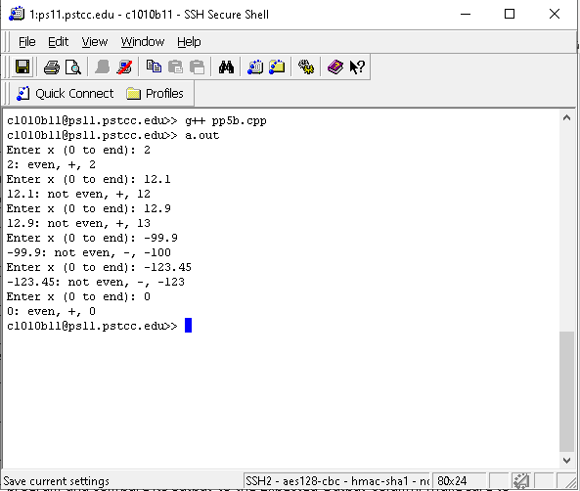

5c (3 points)

**/*File: pp5c.cpp**

**\* Author: Matthew Krahel and Blake Hodges**

**\* This program takes input from the user,**

**\* inputs are name and age. Modifies the**

**\* inputs and outputs different variables.**

**\*/**

**//define library and namespace**

**#include <iostream>**

**#include <string>**

**using namespace std;**

**//define function**

**void getData(int& age, string& name);**

**//Precondition: Two non-assigned variables**

**//Postcondition: Two variables populated from user and outputs to be called by the driver.**

**//main function**

**int main(){**

**//Declare variables**

**int ageGiven;**

**string nameGiven;**

**getData(ageGiven, nameGiven);**

**return(0);**

**}**

**//Function**

**void getData(int& age, string& name){**

**//Prompts User**

**cout << "Enter name:\n";**

**cin >> name;**

**cout << "Enter age:\n";**

**cin >> age;**

**cout << "Your name is " << name << " and your age is " << age <<".\n";**

**}**

